**Rajshahi University of Engineering & Technology**

**Department of Mechatronics Engineering**

**CSE 2188 Lab Project Report**

**2D Game Design**

**Group no: 05**

**Members:**

**Nafees Sadeek (1908023)**

**Tahmid Rahman Shohan (1908024)**

**Anonno Singha Ray (1908025)**

**Shuvo Pramanik (1908026)**

**Mahfuz Ur Rahman (1908027)**

**Under The Supervision of:**

Md. Faisal Rahman Badal

Lecturer

Dept. of Mechatronics Engineering

Rajshahi University of Engineering & Technology

Md. Mehedi Hasan

Lecturer

Dept. of Mechatronics Engineering

Rajshahi University of Engineering & Technology

**Title:**

**Objective: To design a 2d game using python.**

**Theory:**

**Game Design refers to the complete process of generating an idea for a game and taking it all the way to a final, playable product. There are a lot of elements that go into designing a game. And they are:**

* **Core game concept**
* **Game mechanics**
* **Character design**
* **Narrative and plot**
* **Level design**

**Video games need to be coded, tested, and debugged and much more. Ultimately, the goal of a Game Designer is to create a game that is fun. A game that players can enjoy and revisit often.**

**Platforms Used:**

* **OS: The Game runs on any operating system that can use an IDE for python language and has access to keyboard. For this project, Windows 10 operating system was used.**
* **Programming Language: Python programming language was used in suitable IDEs. Along with the standard library, the PyGame library was used.**
* **IDE: Any IDE that can compile python and create a virtual environment can be used. For this project *PyCharm* and Spyder IDEs were used.**
* **3rd party software: For easy level creation, *Tiled* software was used. Canva web based software was used to create the game logo.**

**Assets Used:**

* **Graphics: The pixel art images of the main character (the pirate), enemies, trees, grass, coins and all other visible graphics were downloaded freely from a royalty free website.**
* **Audio: all music and sound effect was downloader freely from royalty free website.**

**Features:**

**Core game concept:**

**A platform game (often simplified as platformer and sometimes called a jump 'n' run game) is a sub-genre of action video games in which the core objective is to move the player character between points in an environment. Platform games are characterized by levels consisting of uneven terrain and suspended platforms of varying height that require jumping and climbing to traverse.**

**Our designed game revolves around the main character running and jumping on an island full of danger where he has to move from the starting position to the objective.**

**Narrative and Plot:**

**The main narrative of our game is the main character, the pirate, having lost all his treasured hats in a storm, along with his ship and crew. He wakes up in an unfamiliar and dangerous island where he must traverse the land, climb trees and defeat enemies to get back his lost hats.**

**Game Mechanics:**

1. **Player Control: The player can move in both directions using the arrow keys. The player can jump and move mid-air as well.**
2. **Enemy Interaction:** Enemies normally move around in a permanent limited space. Player can defeat enemies by jumping on top of their heads. Enemies can also deal damage to the player by running into him.
3. **Coins and Scores:** Player can collect silver and gold coins scattered around the level.
4. The score counts the number of silver coins collected. Each gold coin is equal to 5 silver coins. Each time player completes a level, the score gets added onto the next level.
5. **Win Condition: To win the level, the player has to reach the hat and collect it.**
6. **Lose Condition: Player loses the level if he falls into the water. Upon such failure, the player loses a certain amount of health and restarts the level. Player normally start with a full health each time a new level is selected. Player loses the game, if health reaches zero. Upon such failure, the progress is lost and player must start from level 1 once again.**

**Character Design:**

**The Main character of our game is a pirate. He wears a large hat with a skull symbol and holds a sword. He always wears a smile on his face.**

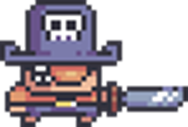

**Animation:**

**Multiple frames of the character, enemies and trees doing different actions have been compiled to make smooth animation. These include:**

* **Main Character idle, moving, jumping animation along with dust clouds whenever he jumps and lands.**
* **Trees swaying in the wind.**
* **Coins moving in circles.**
* **Enemies moving.**

**Level Design:**

1. **Map of the Island(OverWorld):**

The game is separated in 6 complete levels. Each level has to be completed to reach the next level. Unlocked levels can be selected from the map menu.

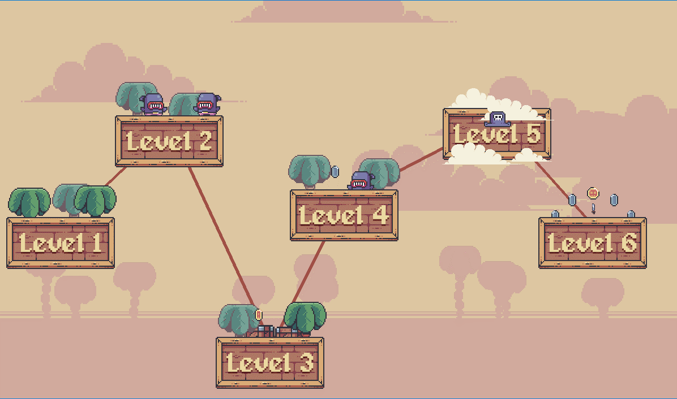

1. **Level Structure:**

**The level is created such that the player always starts at the left side and has to get to the right side where his hat lays.**



1. **obstacles, enemies and others:**

**The Objects, trees, obstacles, chasms and enemies are placed in such a way that gives a challenge to the player. The levels are designed in a way to give each a unique feeling.**

**These obstacles include:**

* **Trees (Both foreground and background) situated on various places on the level.**
* **Enemies situated on strategic locations on the map.**
* **Coins located on hard to get places.**
* **Boxes placed to either help or hamper the player’s movement.**

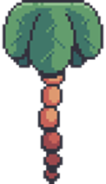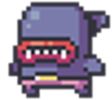 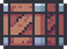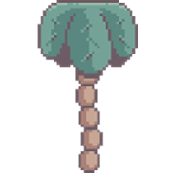

1. **GUI:**

**The GUI (Graphics User Interface) shows the total health, remaining health and the number of coins collected. The GUI is situated at the top left corner of the screen.**

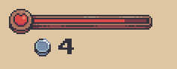

1. **Audio and sound effects:**

**Two types of music were added to the game. One for the island map and other for the gameplay. Sound effect of collecting coins was added.**

**Procedures:**

1. **Operating an IDE:**

**A new project in the IDE, Spyder, was opened. Necessary library and packages were installed. Any errors involving the IDE or the programming language that may occur were solved beforehand.**

1. **Writing Codes:**

**A total of 12 different python files(.py) were created, each used for different sections of the game. Every section is interconnected with each other, taking data from one another, allowing the writing of cleaner and easily understandable codes. Enemy, level, player, setting etc. are some of the sections.**

1. **Creating Levels:**

**The first prototype of the game used bare basic level design. It was wholly created within the ide. Next iteration of the game required detailed levels and therefore a 3rd party software ‘Tiled’ was used. Using Tiled, the assets were placed on a canvas and drawn like a painting to create desired level maps. This data was extracted from the software.**

1. **Importing outside resources:**

**Resources such as graphics, audio, animation, level-design etc. were imported using suitable codes that will utilize these resources when needed.**

1. **Testing, prototyping and debugging:**

**First, the player controls were designed along with player animation. First prototype of the game was tested on blank canvas with simple blocks as land. Many bugs were found and recorded for fixing.**

**Second prototyping involved the use of premade levels with object animations. The new levels were loaded and tested. Decoration was completed, many bugs were found and recorded for fixing.**

**Third prototyping was to test the enamies and player damage system. Same levels were used. moving enemies were tested. Bugs such as enemies falling off the map was found.**

**Fourth prototyping involved fixing previous bugs. Falling enemies bug was solved.**

**In Fifth prototyping, the map menu was completed and 6 total levels could be selected. Many bugs were found and recorded for fixing.**

**In Sixth Prototyping, Audio was included along with coin and score system. Many bugs were found and recorded for fixing.**

**In Seventh and final prototyping, most found bugs were death with. Movement and other sections were further improved.**

1. **Finishing Up:**

**Using auto py to exe, the project was converted into .exe format and saved on hard drive for submission.**

**Bugs:**

**1.We have faced several bugs such as anti-gravity, unable to collide with enemy, enemy falling from platform etc.**

**2.Our executable file crashes frequently.**

**3.The can don’t run smoothly (executable file).**

**Discussion:**

**All of our team members helped each other to make the game successful. There were some difficulties we have faced while making the game such as anti gravity of the players, file error, player’s collecting coin but the score isn’t increasing etc. We have solved these problems by discussing with each other and by watching YouTube videos. But the last problem that appeared while making the executable file is ,it seems to crash all the time while opening the game. We have tried so many time to solve it but we were unable to solve it.**

**Conclusion:**

**The aim of this project was to build a beginner level game and we were pretty much successful in doing so. We have chosen python because it seemed to us the easiest programming language .By finishing the project we have acquired pretty deep knowledge about python and pygame module of python programming language.**